**Submitting Assignments Using Google**

**Helpful Hint: You may want to create a folder for your online courses. If you change the share settings on the folder so “organize, add, & edit” and create/upload all your assignments to this folder, your online teacher will always be able to access your documents! You also can add your teacher email under the share settings and grant them individual permission to edit too and some may request this.**

**To submit an assignment you created using Google docs to your WVS teacher:**

**Step 1: Create a folder using the following steps:**

1. **On your computer, go to drive.google.com.**
2. **Click on create by clicking on the icon on the left side of the Google screen, choose folder.**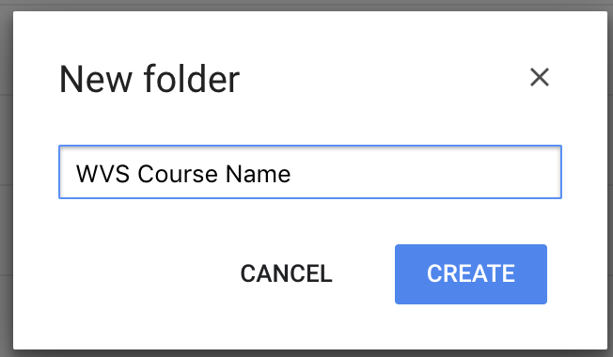
3. **Name the folder with your course name, click create.**
4. **To open the folder, double Click on the folder you want to share.**
5. **Under "People," type the email address or Google Group you want to share with. You will be sharing your folder with me, so type: wvs.nwegter@cesa9.org**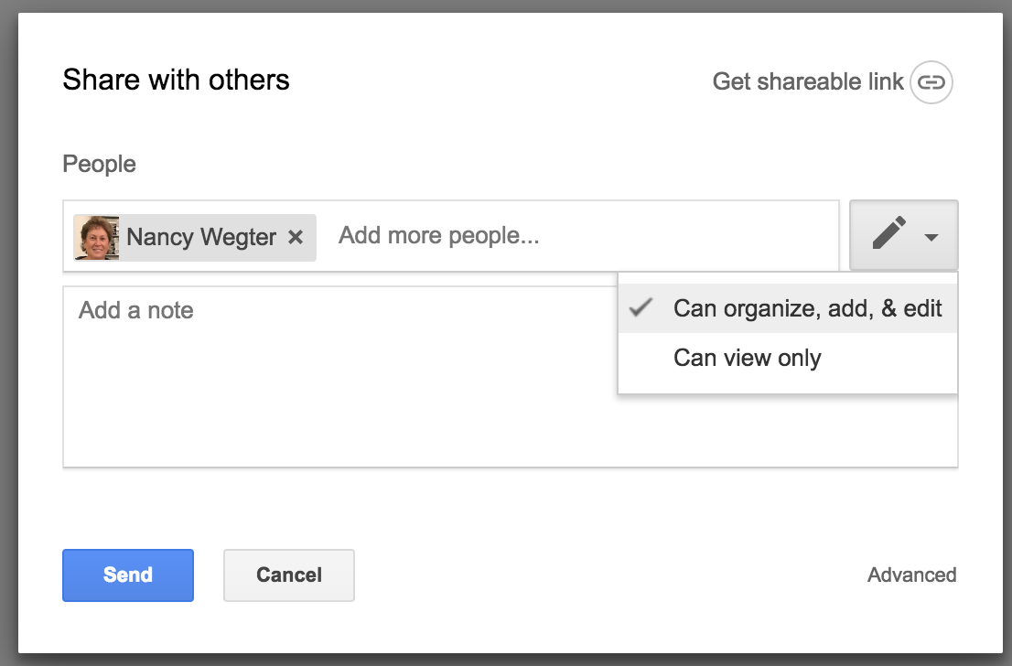
6. **To choose how a person can use the folder, click the Down arrow on the right. Leave the settings as: Can organize, add, & edit**
7. **Click on send**

**See the Video below for a short demonstration of this process:**

[**Creating a Shared Folder in Google Video**](https://drive.google.com/file/d/1XSGrJFYLcqAYFuCPajmfL446LKnu6ggP/view)

**Step 2: Submitting the Google Document.**

**Click on the following video link for a short demonstration on how to submit a Google Document for grading:**

[**Submitting Your Google Document forGrading**](https://www.screencast.com/t/ltwSbMy8)

**You can also download your Google Docs to Upload in another format too and if requested by your teacher:**

1. you can download the file as a rich text format (rtf) or download as a PDF to save and upload as an attachment into the assignment submission area or
2. share the document with the instructor and copy and paste the share link in the assignment submission dialogue box

